City University of Hong Kong

Department of Electronic Engineering



**EE5415**

**Mobile Application Design and Development**

(2019-2020 Academic Year Semester B)

**Android Mobile App Proposal**

**Project Title:**

**[Walletkeeper ]**

|  |  |
| --- | --- |
| Group Number : | [15] |
| Group Members : | Fang Yuxin (55941269)  Li Huimin (55997947)  Shen Yaojun (55988822)  Zhang Jianing (55831831)  Zhou Ziyang(55921210) |

**Section A – Basic Information**

1. **Project Title** 
   1. **English (not more than 20 words):**

Walletkeeper

* 1. **Chinese (not more than 30 words):**

钱包管家

1. **Abstract**

Compared with other bookkeeping apps, Walletkeeper has some features making it outstanding. Firstly, it has a GPS function, which mean, you not only can trace when you have record this bill, but also can trace where you have record this bill, which can make your memory clearer. Secondly, it has a function called ‘wish list’, which is useful for people like students, who don’t have regular income, but need money to support their hobbies, in this function, they can set a ‘wish’ money and the date to achieve this ‘wish’, then xx will give the amount of money that users need to save every day/week/month (it depends on users’ choices ).

1. **Impact and Objectives**
2. **Long-Term Impact:**

However, bookkeeping has many benefits for individuals, families and society. For individuals, it is not only good for developing good personal habits, but also can help to avoid spend money without thinking. For families, it is a useful method for family members to balance the income and expenses, finally, for society, if each members of society has good spending habits, they will consume less resources.

1. **Objectives**

Befriend with good habits and fight with bad habits is the thing that we are doing every day. According to a study published in the European Journal of Social Psychology by researcher prof.Phillippa Lally at the University of London Health and his research team, it takes 66 days to develop a new habit. After that, a behavior can happen naturally and become your habit. Obviously, bookkeeping is a good habit, we design this app to make users can easy bookkeeping so that they can form this habit in the end.

Bookkeeping has so many benefits, for example, you can easily understand in which area you have spent your money, and how much money you have spent on it. Moreover, once you have formed the bookkeeping habit, you can find many other benefits which can improve your living standard.

1. Firstly, you can find the price of an item is expensive or cheap through your records. Taking myself for example, I can easily find the suitable price for vegetables, however, I also find the price for each items will change randomly every day, and I will buy more vegetable if the price is good today, which can also help me save money.
2. What’ more, bookkeeping can also increase you sense of investment. That mean, bookkeeping is a process that convert daily routine into numbers, and you can judge the situation of your assets easier, so as to plan your investment.
3. Moreover, review your record regularly can help you find your problem, for example, you may find you have spent too much on entertain but pent less on your parents. Thus, to enhance the relationship with your parents(though you needn’t do anything, they are always the people who love you most in the world), you will plan to buy some gifts for them, which will make them happy .

In conclusion, WalletKeeper is a good app which makes bookkeeping easier and helps you to form a good habit of bookkeeping. We all need know that our daily lives are all connected to money, like food and medical, so we need to spend money with plan and make full use of it. Therefore, xx is a convenience app for people to form the habit of bookkeeping, because you can note your bill anywhere once you have a smart phone that downloaded this app, and the GPS and note functions are good for you to trace your memory, thus you can remember each bill clearly, and it is helpful for you to summery your consumption.

Once you have kept bookkeeping and formed this habit, you will find each expense of you will be helpful and meaningful, finally, your lives standards will improve and your deposit will be abundant.

**Section B – Background**

**1. General background**

With the improvement of people’s income level and living standards , the trend of diversified consumption becomes increasingly obvious. Compared different views of money between young and old, the young generation have a high enthusiasm for new consumption methods and concepts. For example, they are not holding back and trying to get a better grip on their balance sheet anymore, like their parents, sometimes even over-spend. This makes their actual consumption and plans unmatched, which causes unnecessary trouble. Building a bookkeeping habit can help people understand their expenses, manage and restrain their own inappropriate consumption habits. As the increasing popularity of smart phones in people's lives, the need for smart phone-based personal accounting and financial analysis tool growing importance, bookkeeping mobile application shows huge potentially market.

This project aims to develop an individual bookkeeping app based on Android Studio. Nowadays, all kinds of mobile application industries make developer dazzling, like Symbian system, IOS, Windows Mobile, each of which has its own advantages and disadvantags. For example, the Symbian system has a lower hardware configuration and a lower processor frequency for various models. Although the system can achieve higher processing performance, it still has poor compatibility between multimedia and versions. In addition, Microsoft’s Windows Mobile operating system has higher requirements for hardware and operations， which is not friendly to those unskilled person. For beginners, Android is easier to get started.

Android is a, developed by the Open Handset Alliance, Linux-Kernel NetBSD-Userland based operating system for Smartphones, Tablets and other mobile devices, as well as other embedded devices, like cars. It is widely used in app developing. In the 4th quarter of 2015, Android had a market share of over 80 % (80.7 %) in the distribution of operating systems in of mobile operating systems①.

There are some outstanding advantages for Android system.

1. Openness: One of the biggest draws to the Android platform, the “open” system over the “closed” Apple IOS, create a free environment without over-regulation that allows any developers to join Android Market and develop their own apps. This app ecosystem is attractive to both customers and developers alike. With the increasing number of users and apps, a new platform will become mature soon.
2. Hardware support: This is still related to the openness of the Android platform. Due to the openness of Android, many developers will launch a variety of products with various functions and unique features. While, the differences and features in function will not affect data synchronizations and even software compatibility. Data can be transferred easily.
3. Development language: Android applications use Java and Kotlin as official development language, in which the mainstream development language is Java language. It can be said that almost all of Android applications are developed by Java language. It is a simple, universal, object-oriented, secure, portable, and high-performance language.

According to "China Accounting and Financial App Mobile Market Quarterly Monitoring Report 2015 Q4" reported by Analysys②. Data shows that the total number of active users of China's accounting and financial app increased significantly, the number of daily users has reached 16 million. The increase in the number of people using accounting applications is directly related to the popularity of mobile phones, insisting in bookkeeping can make user feel a sense of accomplishment. Nevertheless, for app developers, tool apps can easily fall into the competition of homogeneity, it is necessary to design a distinctive function for attracting users.

**2. Market Research**

Take three bookkeeping apps as an example, they are not significantly different in the overall architecture, even very similar in user interface design and report output. However, in terms of function selection and operation optimization, there are still differences. The following is a selection of three bookkeeping app, Daily Cost, Shark Accounting, and Fortune City for comparison and analysis.

In terms of product functions

1. Daily Cost: It is easy and convenient for accounting, and provide multiple currencies as unit of account. This function makes app more international and facilitates people who travel overseas frequently. However, it is precisely because the product orientation is simple, there is no extra functions except basic accounting. That seems to be low price performance radio compared with high price in Google play store and App store.
2. Shark Accounting: The most distinguishing feature is that there is no independent user system in app. Users can synchronize their icloud or Google account in app without new enrollment, so that we can use it directly after downloaded. Besides notification setting is available—ability to remind users to add daily expense on time.
3. Fortune City: This is a good combination between recording daily expense and simulation games like SimCity, thus making bookkeeping much funny and less boring. That is both a strength and a weakness. Due to game-play, user interface and operation are more complicated than other bookkeeping apps.

Figure1: Basic function (Daily Cost, Shark accounting, Fortune City)

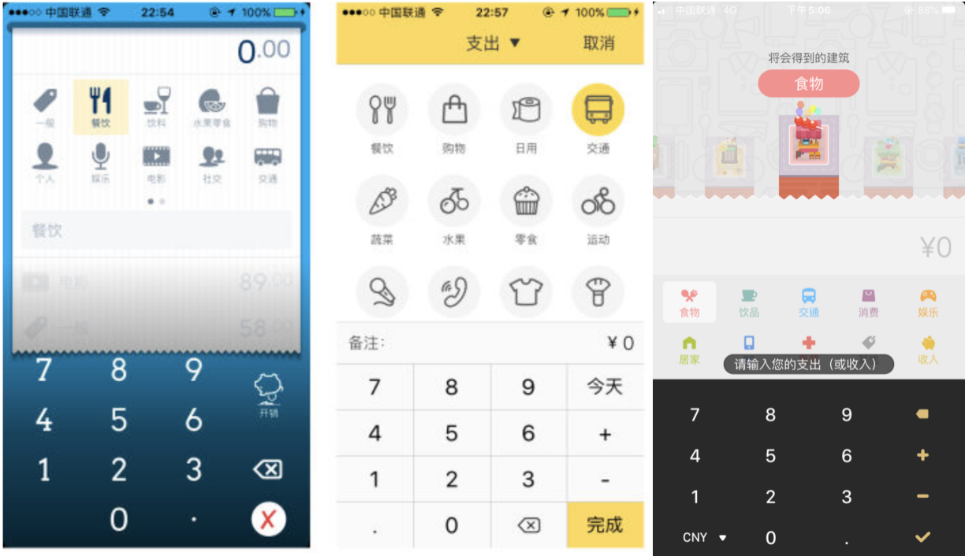

Another important function is the chart of account to analyze receipts and payments. The statement of account is something that every bookkeeper will care about. From the chart, they can find their own income status and arrange property income appropriately. Thus for an bookkeeping software, its account expression can also be used as a criterion for determining whether the App is "good".

Figure 2: Account statement (Daily Cost, Shark accounting, Fortune City)

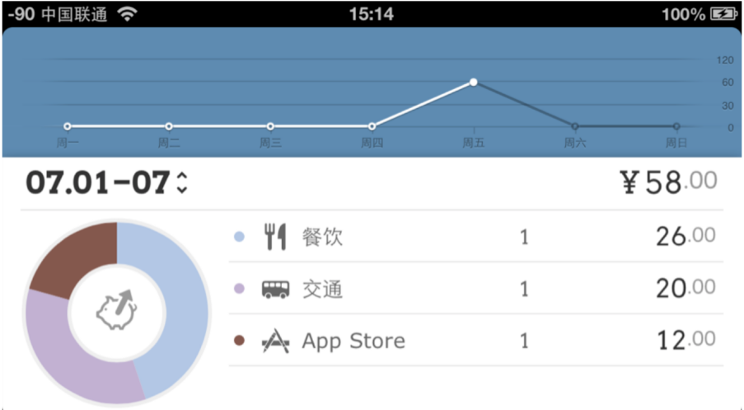

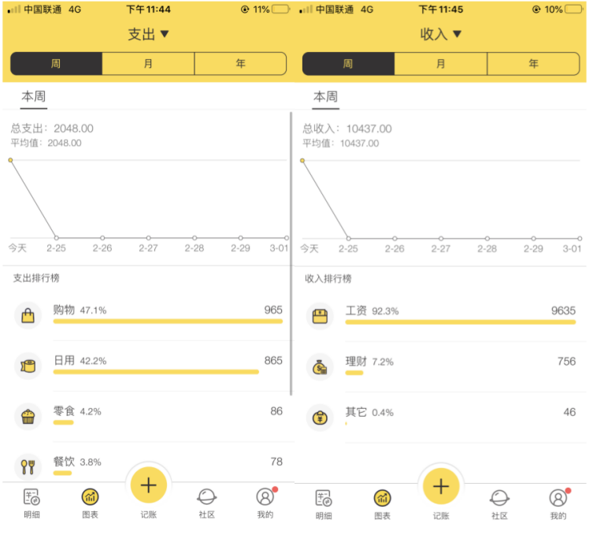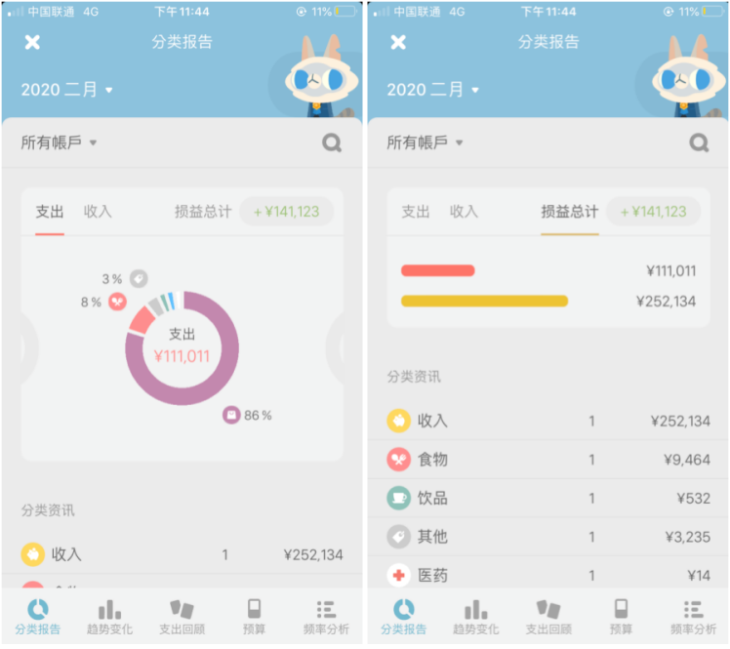

1. Dailycost is more comprehensive in the form of the account statement. It also uses line charts and pie charts to list the bill details in units of days. The line chart of the week is shown above, which is very simple and clear, allowing users to understand the expenditure promotion of each part and spending trends.
2. Shark Accounting mainly uses line charts, but you can query spending trends by week, month, or year. It displays expense and incomes details in a streamlined manner with clear and intuitive information.
3. Fortune City uses histograms and pie charts. The pie charts are used to show the cost ratio of each part. The histograms are used to visualize the balance of payments, so that users can intuitively understand their debts and balances.

As for the profit model, most bookkeeping apps are mainly make profits by inserting advertisements in user interface or upgrading VIP to enable more functions.

**Section C – Design Details**

**1. App Design**

The framework of this bookkeeping app is shown below, which contains five main functions, accounting, details, diagrams, community, me.

The accounting function is record the bill details including the category, price and the location in time. The details function is show the details for each bill the user recorded in accounting function. The third function is the diagrams function, which use the chart to show the change of daily income and expenses directly. In the community function, users can post their wishlist or share the financial tips on that, they can also read others article about investment guides to accumulate wealth and achieve the wish in wishlist faster. In Me function, users can set their monthly budget and set the wishlist here, at the same time, this function will show the details about budget(remain budget, monthly budget, expenses in this month).

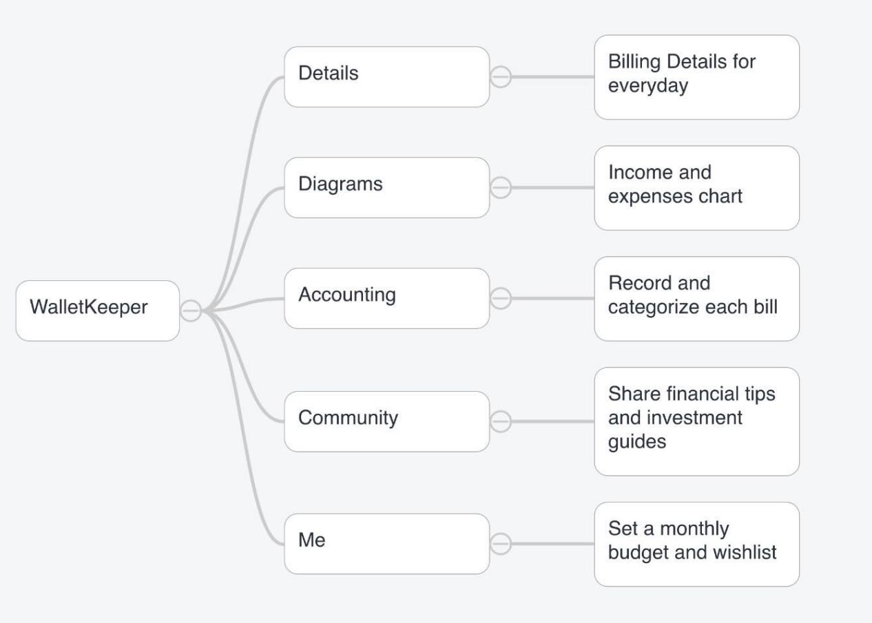

1. Login:

Users need to input their name and choose to Wechat login or Google login, then they can enter this app.

(2)Home: The default home page of this app is shown below, users can choose the function they would like to use, and start to accounting right now.

(3)Accounting function:

Users can record the details about the expense or income, input the price, category, remarks and location(GPS),then click the record button, the bill recorded can be found in details.

(4)Details function:

In this function, users can see the sum of income and expenses this month and the total bills for each category, which is rank in ascending order.

(5)Diagrams function:

This function show the expense daily in the form of a line chart, and the users can select week, month, year button to see the corresponding line chart.

(6)Community function:

Users can post their ideas or share their bill in this community, typing the title and the content and click send.

(7)Me function:

Users can set the budget and wishlist, in this page will show the details and schedule about the budget and wishlist, at the bottom of this page, users can add other wishes in wishlist.

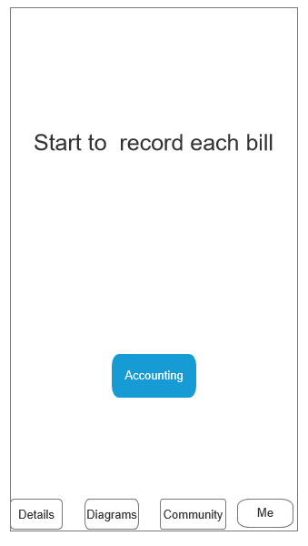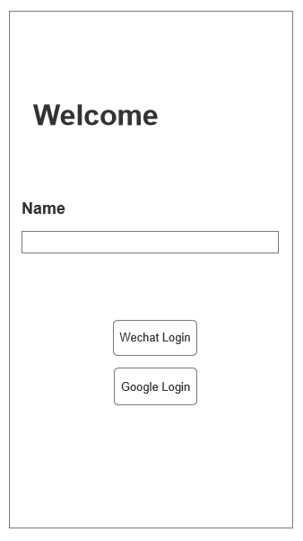

Figure (1): Login Figure(2):Home

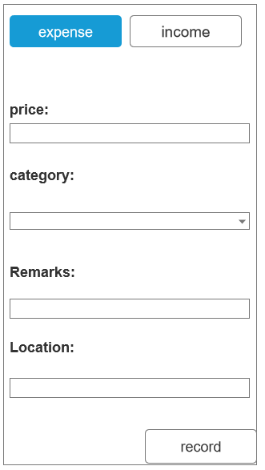 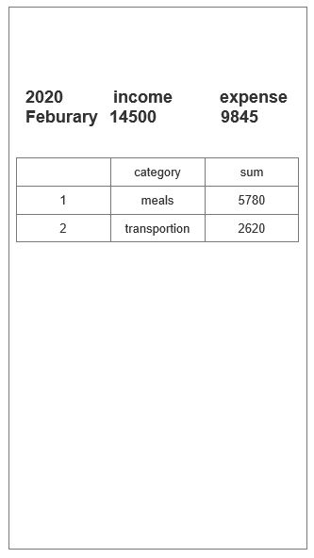

Figure(3) :Accounting function Figure(4): Details function

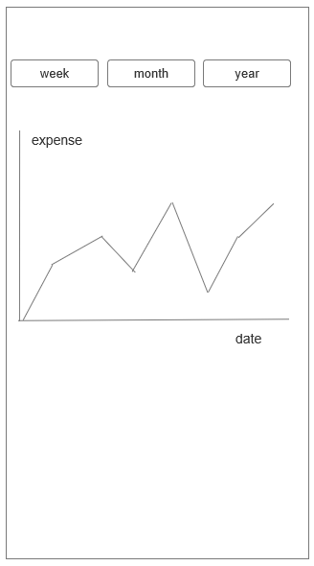

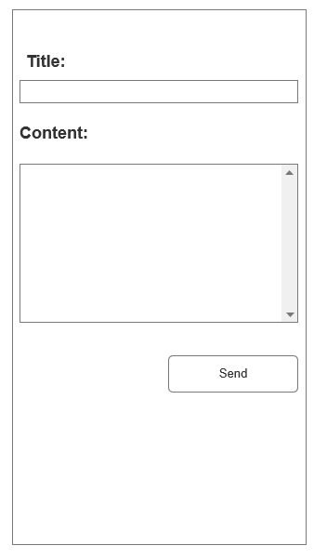Figure(5): Diagrams function Figure(6): Community function

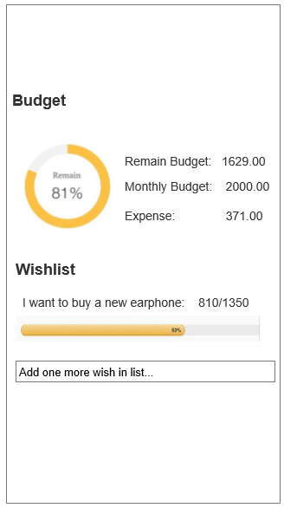

Figure(7): Me function

1. **Methodology**

We will use Android Studio as development tool,and calling SQL database,use java as the develop language. Apply the Wechat OAuth2.0 authorized to log in the app, and use the plug-in rxjava to organize and calculate the bills.

**Section D - Project Milestones**

|  |  |  |
| --- | --- | --- |
| **Period** | | **Milestones** |
| **From**  **(dd/mm/yyyy)** | **To**  **(dd/mm/yyyy)** |
| 27/02/2020 | 05/03/2020 | Confirm the framework and discuss how to implement |
| 06/03/2020 | 12/03/2020 | Implement the wechat login function |
| 13/03/2020 | 19/03/2020 | Implement the accounting and details functions |
| 20/03/2020 | 26/03/2020 | Implement the diagrams and a part of community functions |
| 27/03/2020 | 03/04/2020 | Implement the wishlist and monthly budget functions |
| 04/04/2020 | 20/04/2020 | Discuss about how to improve some functions ,write the project report and prepare for presentation |

**Section E - References**

[1]Smartphones: Android steigert Marktanteil auf über 80 Prozent | ZDNet.de. 19.

[2]Analyaya.China Accounting and Financial App Mobile Market Quarterly Monitoring Report 2015 Q4[EB/OL].https://www.analysys.cn/article/detail/17579, 2016-03-09